Supplementary Material 16: A two-stage model for PCR amplification

- A two-stage model for PCR amplification
We define a two-stage stochastic model to describe the amplification process of a specific target molecule. Let  denote the number of starting molecules. After  PCR cycles, we distinguish two populations of amplicons:  denotes the number of medium-sized fragments amplified with the forward primer only, and  denotes the number of short fragments amplified with both the forward and the reverse primer.
We define  as the probability that any starting molecule successfully produces an -fragment in a given cycle, and 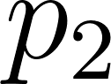 as the probability that any -fragment successfully produces an -fragment in a given cycle. Both  and  are assumed to be constant across cycles and independent between molecules. For notational convenience, we write 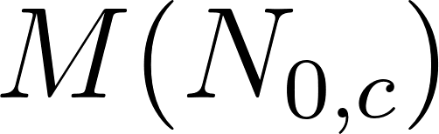 and 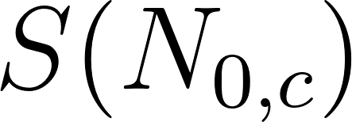 for the expected total numbers of - and -fragments after  cycles, respectively, making the dependence on  explicit in the argument.

- Expected number of M-fragments

In each cycle, every starting molecule independently produces an -fragment with probability . Formally, the number of new -fragments produced in cycle  is a random variable 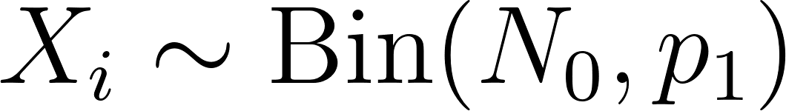, with 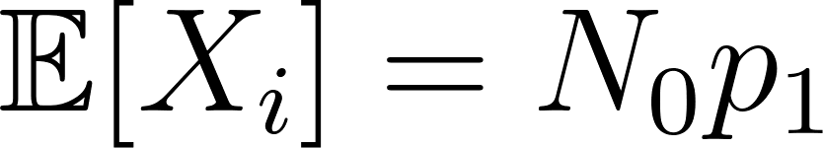. Summing the expected per-cycle contributions over all  cycles gives:

- Expected number of S-fragments

Once produced, -fragments are no longer subject to primer competition and simply double with each additional PCR cycle. New -fragments are generated from -fragments present at the end of the preceding cycle. This leads to the following recursion:

with initial condition 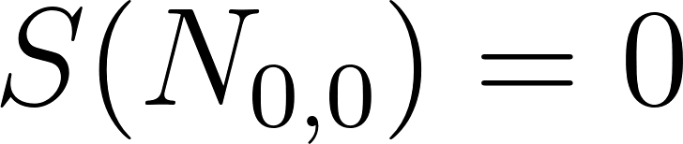. The first term captures the expected number of new -fragments generated from -fragments in the preceding cycle; the second term captures the doubling of all previously accumulated -fragments.

To solve the recursion, we apply it a second time by substituting :

Continuing this unrolling until the initial condition  is reached gives:

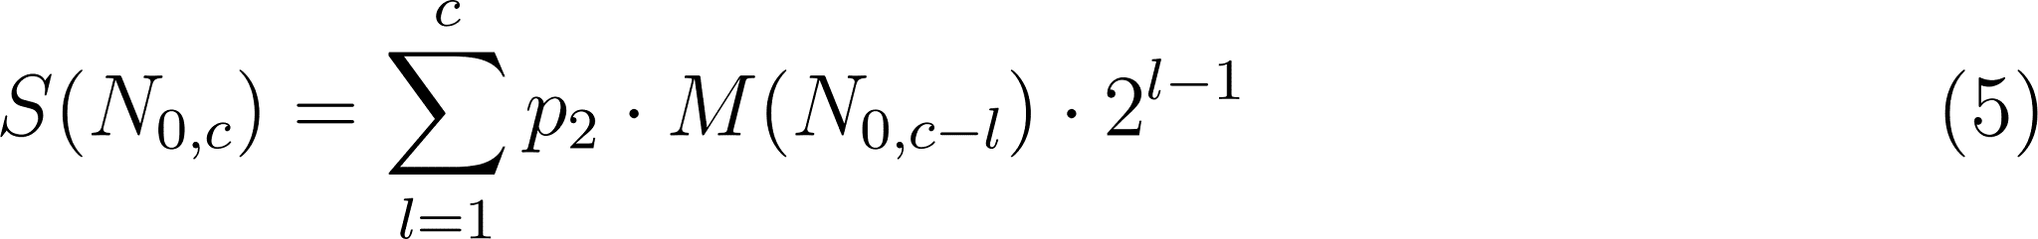

Substituting (the 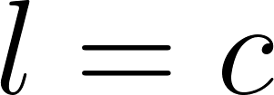 term vanishes since 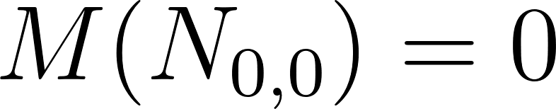) yields:

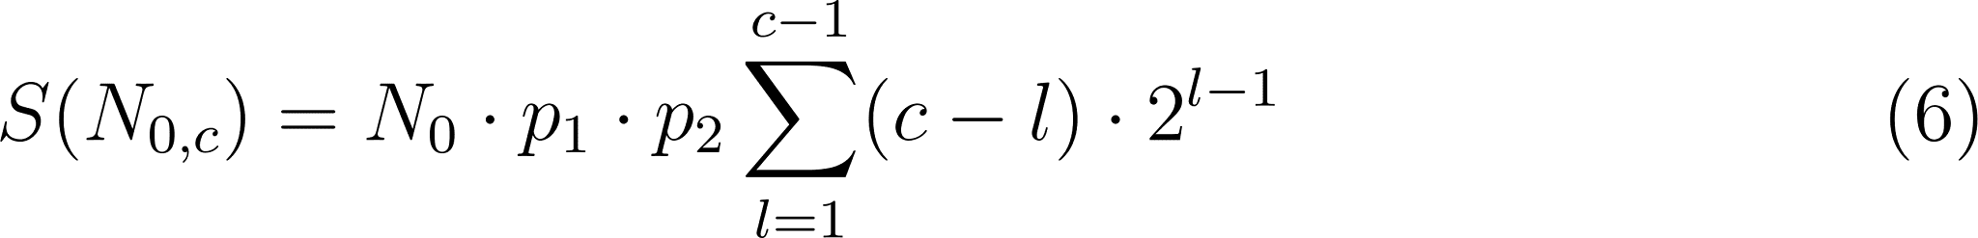

This sum can be evaluated either by applying the geometric series formula (differentiating the standard geometric sum with respect to the ratio) or via a combinatorial argument (see Appendix A.1 for both proofs). Either way, one obtains:

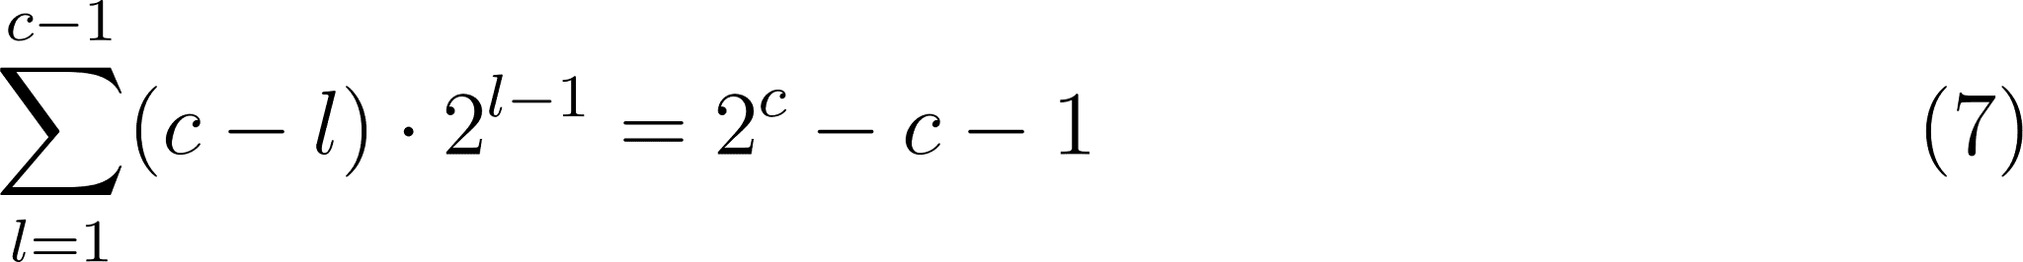

and therefore the closed-form expression:

For large , the linear term 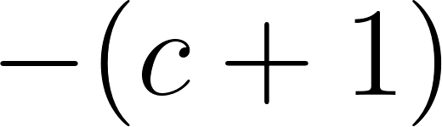 becomes negligible relative to , and the expected number of short fragments grows approximately exponentially:

This is consistent with the well-known exponential amplification behaviour of PCR.

- Amplification efficiency and relative reads

Since  and  act exclusively through their product in the expression for , they cannot be estimated independently from sequencing data. We therefore define the combined amplification efficiency

which yields the final expression:

As the absolute number of -fragments cannot be observed directly from sequencing, we work instead with relative read counts. For a sample containing  distinct taxa, we define the relative reads  of taxon  as:

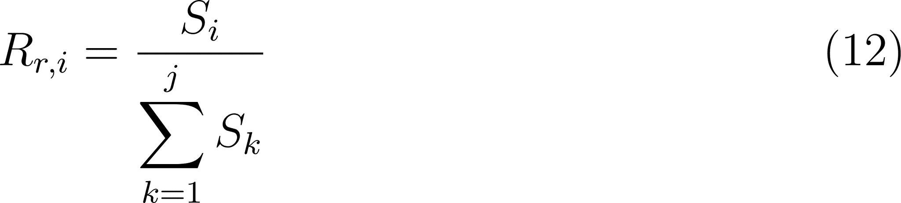

Substituting for each taxon, the factor 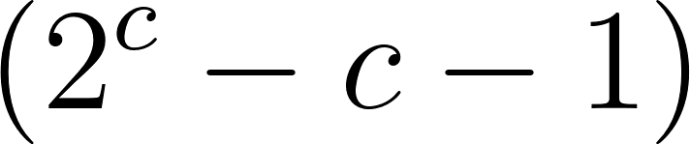 cancels, giving:

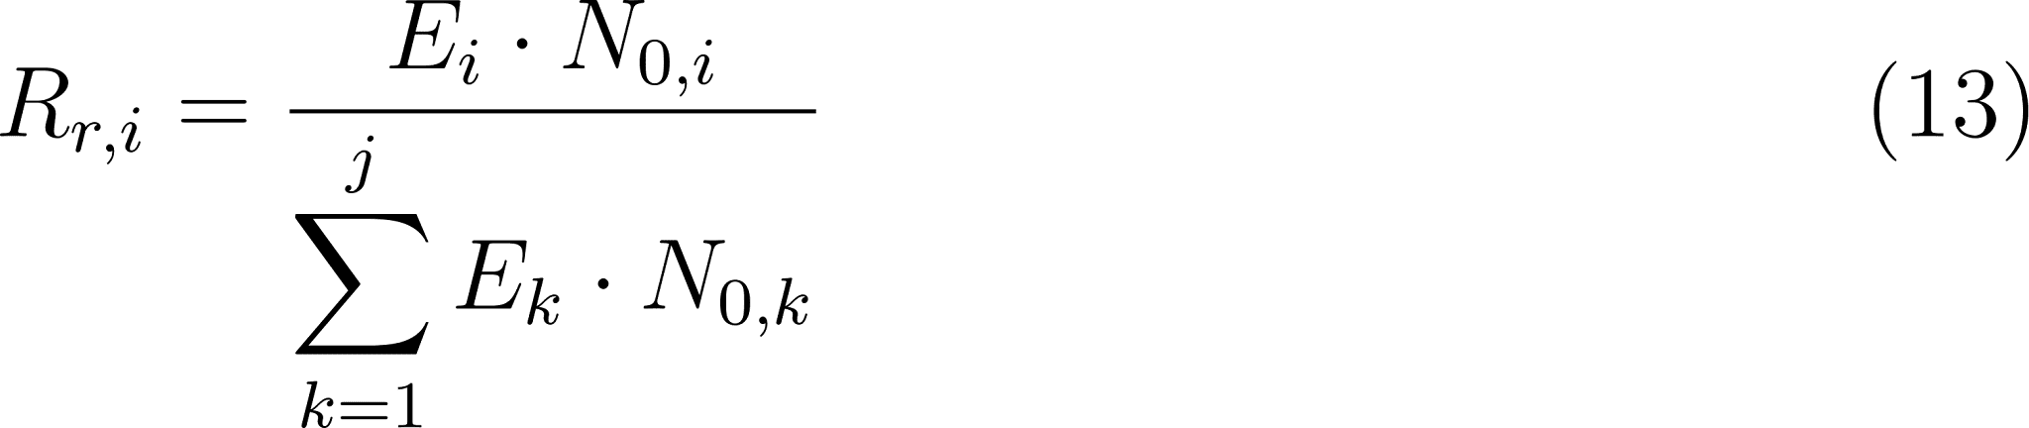

This shows that the relative reads depend only on the product of amplification efficiency and initial template abundance for each taxon, and are independent of the number of PCR cycles . Here,  denotes the expected number of short fragments (Section 3); in practice, observed read counts serve as estimates of these expectations, an approximation that is highly accurate when initial copy numbers  are large — as is typically the case in PCR-based assays (see Appendix A.3 for details).

Solving for 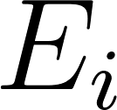 yields (see Appendix A.2 for the full derivation):

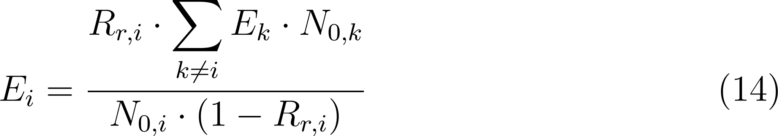

Note that this expression is implicit:  is given in terms of the efficiencies  of all other taxa. A fully explicit solution therefore requires that the efficiencies of the remaining taxa are known — for example, by including a reference taxon with a characterised efficiency. In practice, this means  can be estimated from observed relative reads provided that a suitable reference is available.

For all communities containing only the reference taxon and one other taxon, the efficiency of the second taxon was calculated in relation to the efficiency of the reference taxon (Table 1). These relative  values were subsequently employed to predict the relative copy number from the relative reads measured after sequencing. The predicted relative copy number  for any taxon  follows directly from rearranging the expression for . Solving for  gives 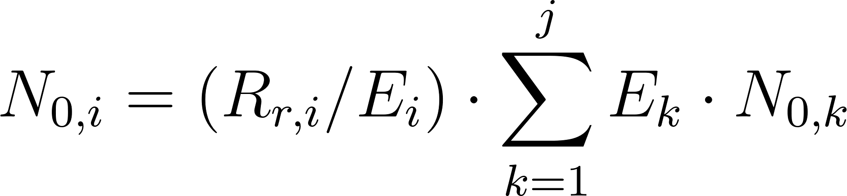, where the sum is the same constant for all taxa. When forming the ratio 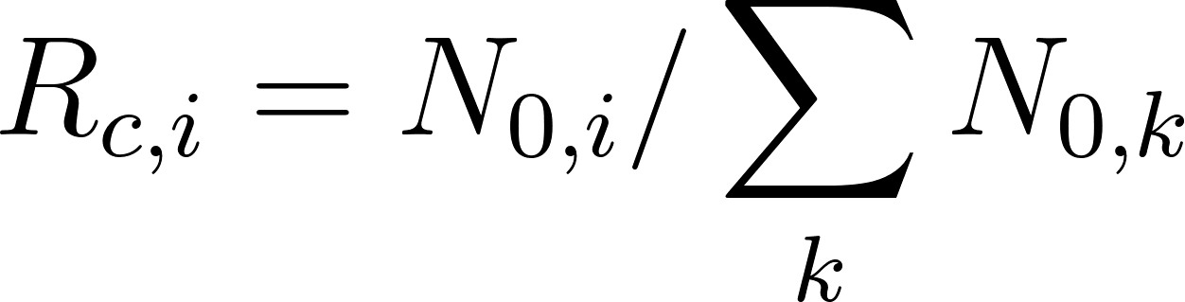, this constant cancels, yielding:

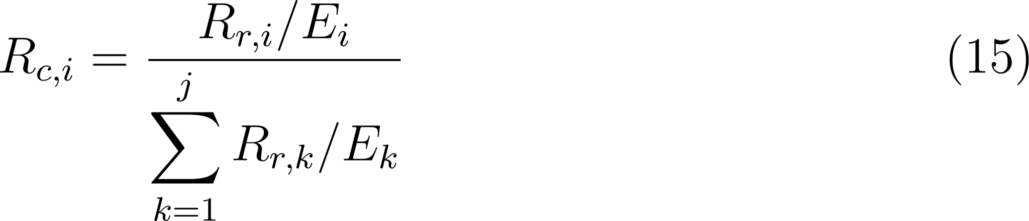

This form is convenient for computation: each taxon's reads are divided by its efficiency, and the results are renormalised across all  taxa. It corrects for amplification bias by down-weighting taxa with higher efficiency.

An equivalent expression, obtained by dividing numerator and denominator by 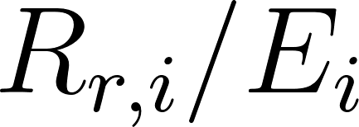 and using 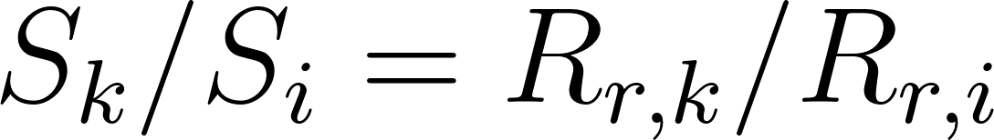 (where  denotes observed read counts), is:

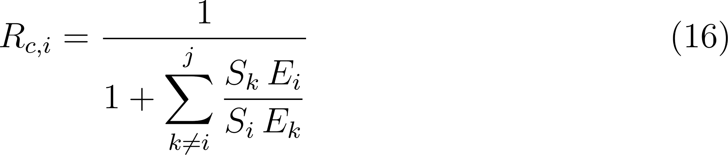

This form makes the pairwise structure explicit: the sum contains one term per competing taxon, each comparing the ratio of observed reads  to the ratio of efficiencies 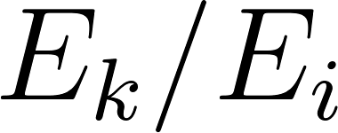. If taxon  amplifies more efficiently than taxon  (i.e. ), its reads are proportionally discounted, increasing the estimated copy number of taxon  relative to . The statistical justification for using observed reads and estimated efficiencies in place of their population-level counterparts — and the consistency of the resulting estimator — is given in Appendix A.3.

Appendix A: Mathematical details

A.1 Proof of the identity used in equation (7)
We prove the identity already stated as Equation (7) in the main text, for all integers :



Proof 1: Analytic derivation
We split the sum using linearity:

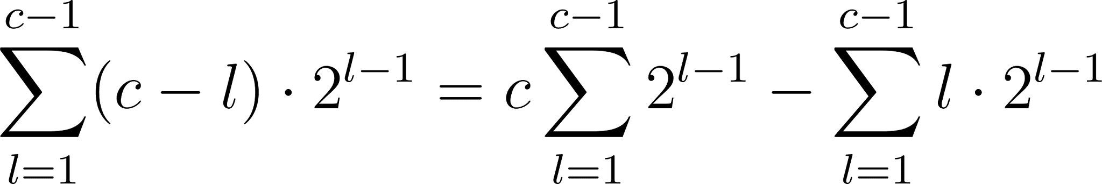

First term. By the geometric series formula 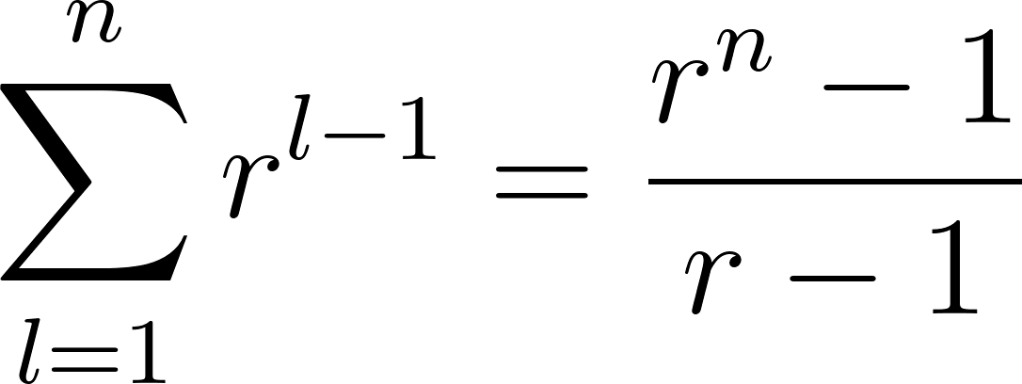, applied with :

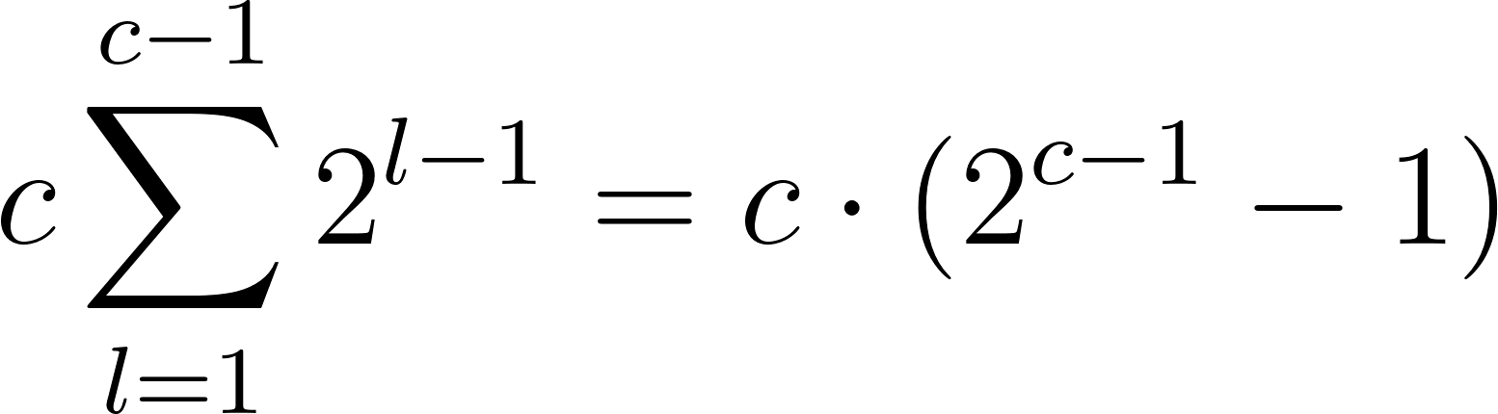

Second term. Differentiating the geometric series 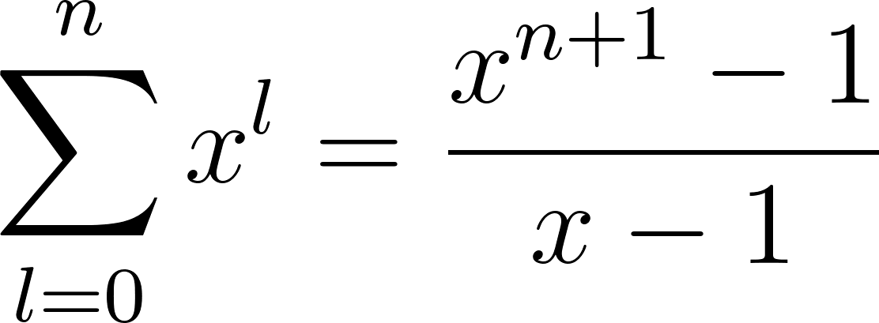 with respect to  yields 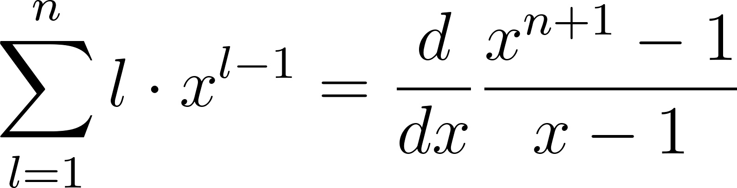. Evaluating at , :

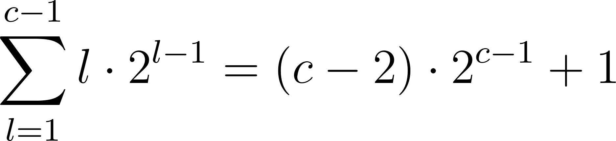

Combining both terms:

Proof 2: Combinatorial argument (double counting)
Claim. Both sides of (A.1) count the same finite set.

Let  be the set of all binary strings of length  that contain at least two ones. Counting directly by complement:

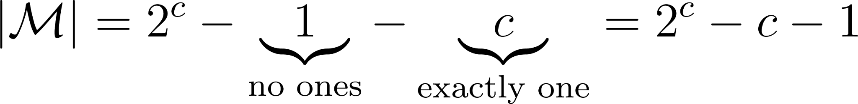

We now count  again by classifying each string according to the position of its second-to-last one (i.e., the rightmost one that is not the last one). Let  denote this position. For a fixed , a string in  with second-to-last one at position  is uniquely determined by:

Segment | Constraint | Choices
Positions 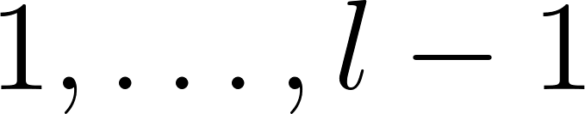 | arbitrary bits | 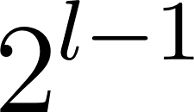
Position  | must be one | 
Positions 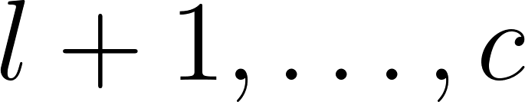 | exactly one among 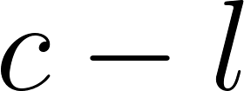 bits | 

This yields 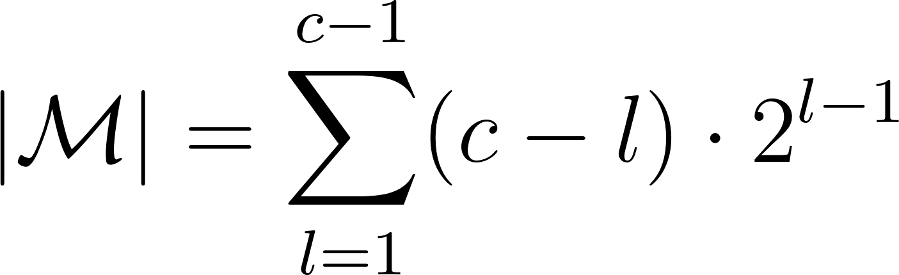, and together with the direct count the identity (7) follows. 

A.2 Derivation of the amplification efficiency  (Equation 14)
We derive Equation (14) from the main text in full. Starting from the expression for relative reads (Section 4):

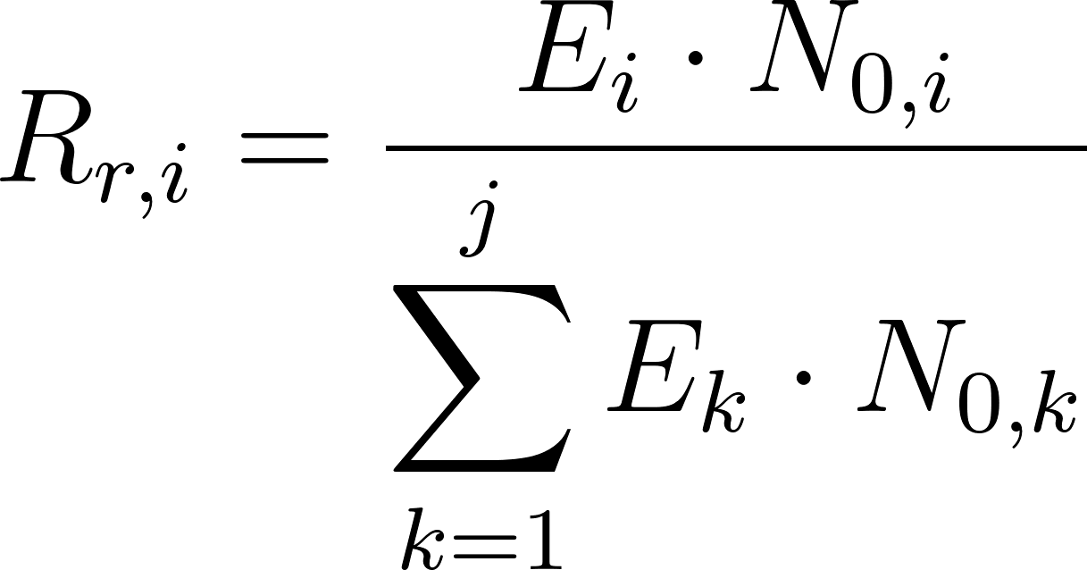

Multiply both sides by the denominator:

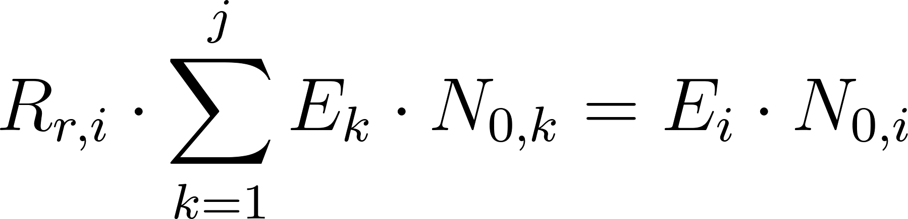

Separate the 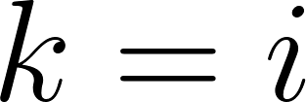 term from the sum:

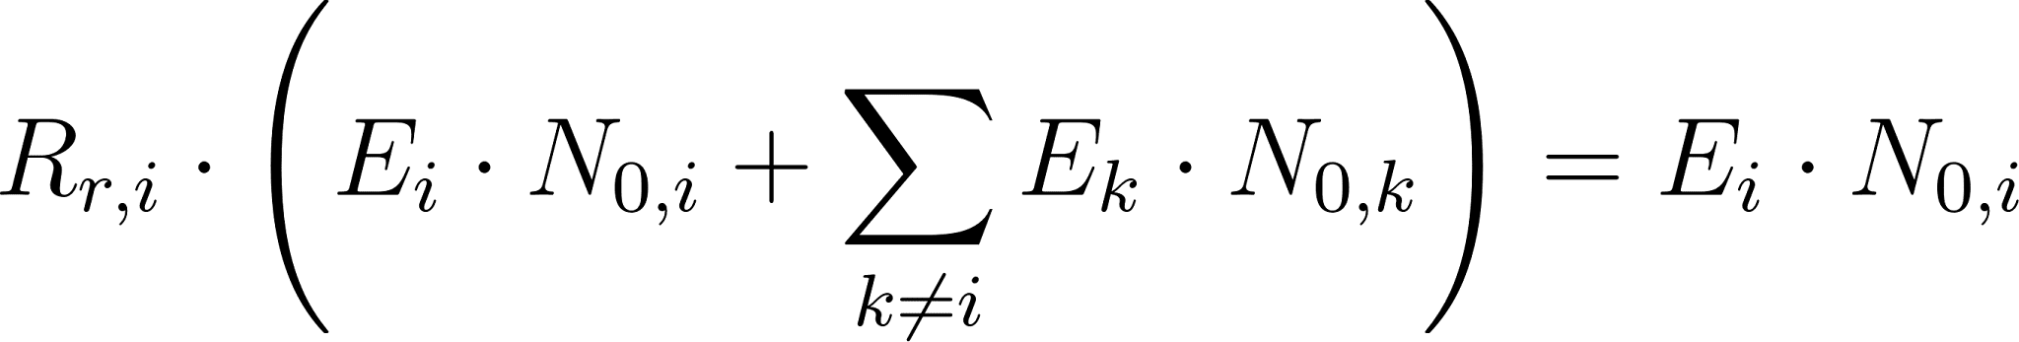

Step 3 — Expand:

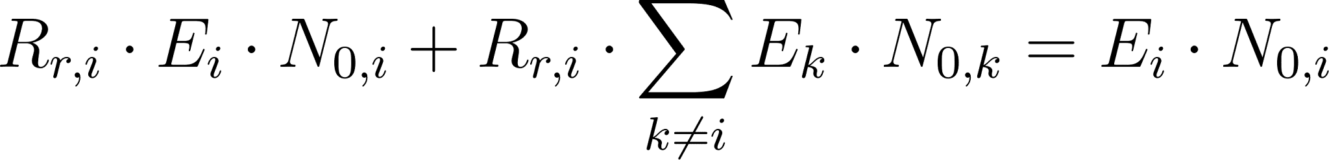

Step 4 — Collect all  terms on one side:

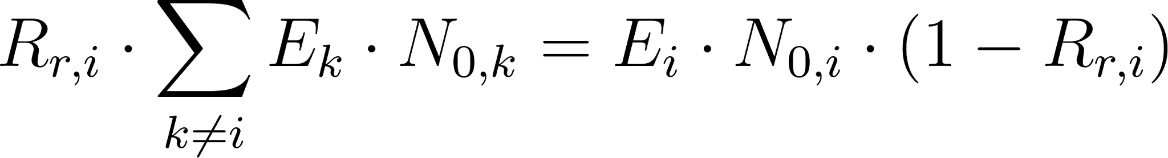

Divide by , valid provided 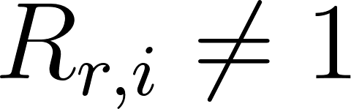 and 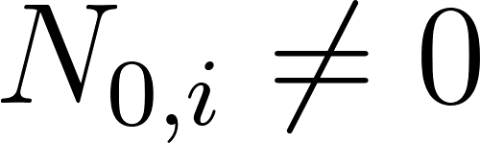:

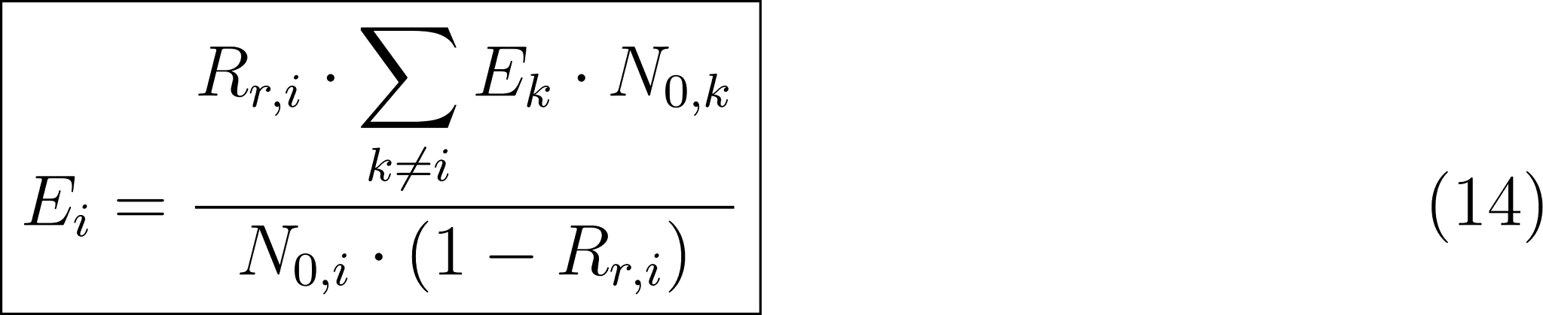

Note that this result is implicit:  is expressed in terms of the efficiencies  of all other taxa. A fully explicit solution is only possible when the efficiencies of all remaining taxa are treated as known — for example, by designating a reference taxon with a characterised efficiency.

A.3 Approximation in the relative read formula
The formula derived in Section 4, Equation (13),



is obtained by substituting the expected fragment counts  into the ratio. It therefore represents 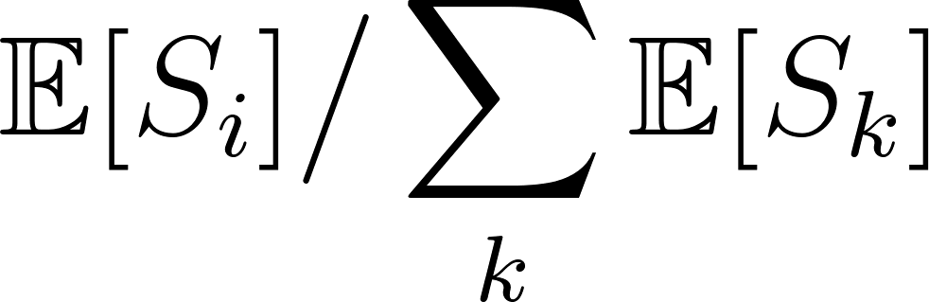, not the expectation of the observed ratio 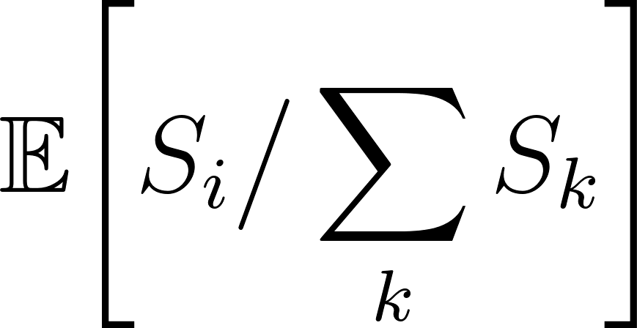. For random variables, these two quantities are in general not equal.

The  starting molecules of taxon  are independent and identically distributed. Denote by 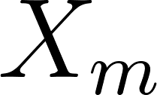 the total number of -fragments produced from the starting molecule  across all  cycles. By the model assumptions, the  are i.i.d. with , and the total fragment count decomposes as:

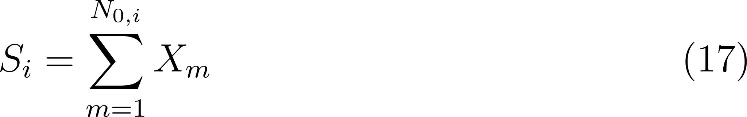

The Law of Large Numbers therefore gives:

Applying the same argument to every taxon  independently:

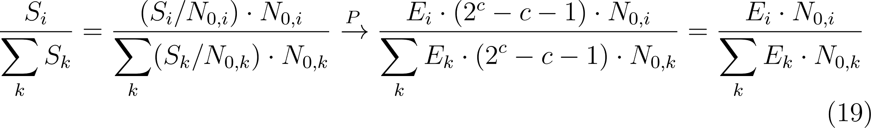

where the factor  cancels, and convergence of the ratio follows from the Continuous Mapping Theorem: the function 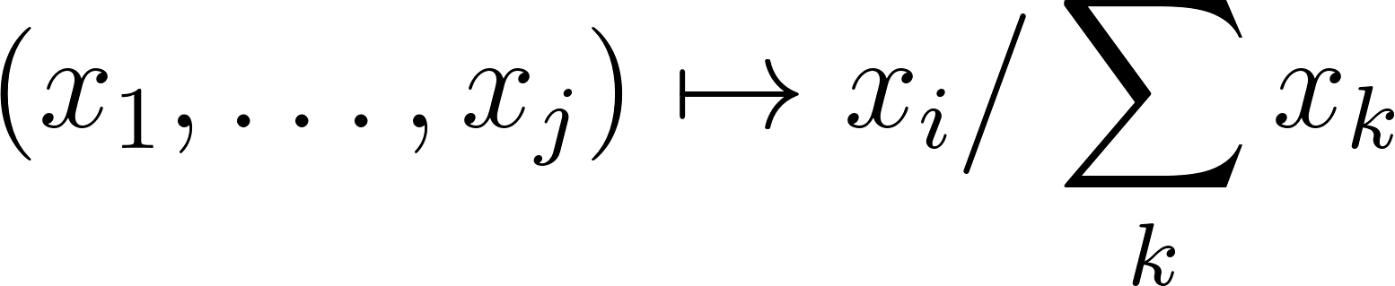 is continuous wherever the denominator is non-zero.

In practice,  is computed by plugging observed read counts  and experimentally determined efficiency estimates into the formula. The argument above shows that  converges in probability to the deterministic expression 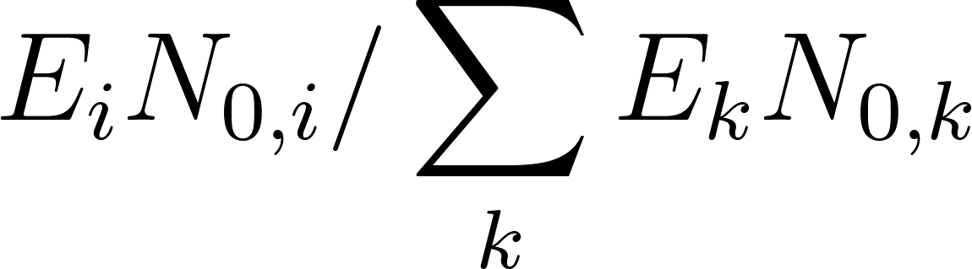 as . In the calibration experiments, all quantities except  — namely , , and  — are known and controlled. The efficiency  is therefore computed as a deterministic function of the observed  alone. Since  is itself a random quantity (PCR is a stochastic process), so is the computed ; it is an estimator of the efficiency. By the same LLN argument as above,  in the calibration experiment converges in probability to its deterministic counterpart as , and a second application of the Continuous Mapping Theorem gives that the computed  converges in probability to the true efficiency, and consequently that the estimate of  converges in probability to the true relative copy number, i.e., the estimator is consistent.

